**2022-2023 KCCD Board of Directors Nominees**

**Kristy Hale**



Kristy Hale started her correctional career in 2019 and is currently the Classification, Re-entry, and Transfer Coordinator as well as the Records Supervisor at the Lee Adjustment Center – CoreCivic. She earned a Bachelor’s Degree from Lindsey Wilson College in Human Services and Counseling and served as the cohort leader during her college career. During her career, she has been awarded the 2019 CoreCivic – Lee Adjustment Center Employee of the Year as well as the 2019 Adult Institutions Award and was recently designated as a Facility Duty Officer. She has served as the Red River Gorge KCCD Chapter President since 2020 and was the Chapter President Elect prior to that in 2019. When she isn’t performing her work duties or striving to raise funds for her local KCCD Chapter, she hikes with her family across Kentucky and road trips throughout the United States while photographing her journey for others to enjoy.

**Pam Clayton**

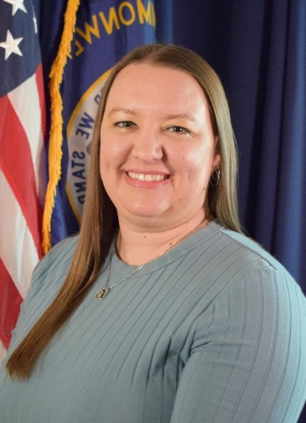

Pam Clayton began her career with the Kentucky Department of Corrections in 2008 as a Correctional Officer at the Kentucky State Reformatory. In 2010, she promoted to the Kentucky Correctional Institution for Women, where she held the positions of Classification and Treatment Officer, Assistant Unit Administrator, and Unit Administrator. During her tenure at KCIW, she worked in each of the facility’s living units, including General Population, Minimum Security, Restrictive Housing, Medical and Mental Health, Substance Abuse Program, and the Assessment Center. She also served on the facility’s Crisis Negotiation Team. In 2018, Pam transferred to the Central Office PREA Branch as a Program Administrator, and in 2021 promoted to the role of Justice Program Supervisor over the department’s PREA Branch. In this role, she serves as the statewide PREA Coordinator for the Kentucky DOC and monitors PREA compliance and investigations for the 14 Kentucky DOC adult institutions and 35 Re-Entry Service Centers. Additionally, she provides training on several PREA-related topics to adult institutions, the Division of Probation and Parole, Re-entry Service Centers, and local jails. She holds a bachelor’s degree in psychology and a master’s degree in justice administration from the University of Louisville.

Pam has been a Department of Justice certified PREA Auditor since 2014.

Pam was the recipient of a DOC Achievement Award in 2016 and a Deputy Commissioner’s Award in 2020.

Pam is an active member of the Louisville Chapter and has served on the KCCD Board of Directors since 2017, including a term as KCCD President in 2020-2021. Pam also currently serves as the Kentucky state representative for the Southern States Correctional Association.

**Shannon Butrum**

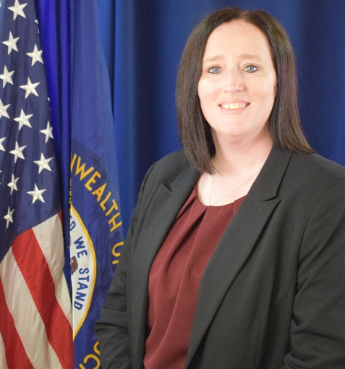

Shannon Butrum began her career with the Department of Corrections in 2001 as a Correctional Officer at the Kentucky Correctional Institution for Women. She was promoted to Sergeant in 2004 and again to Lieutenant in 2006. In 2007 Shannon was promoted to the position of Procedures Officer where she over saw the ACA accreditation process for the institution as well as the addition, revision, and distribution of policies. In 2013 Shannon was named as the institution’s PREA Compliance Manager and helped lead KCIW to a perfect score during its initial PREA Audit, the first audit for the Department. Shannon was promoted to the position of Assistant Director/PREA Coordinator for the Department in 2019. Shannon held that position until being reassigned to help establish the newly formed Compliance Division in 2021.

Shannon has been a Department of Justice certified PREA Auditor since 2014.

Shannon was the recipient of an Achievement Award in 2011 and a Commissioner’s Award in 2015.

Shannon has been an active member of the Louisville Chapter of the Kentucky Council on Crime and Delinquency since 2007, has served as a Director on the State Board and is currently the State Board Treasurer.

**Brandy Aston**

Brandy Aston began her career with the Kansas Department of Corrections in 2009 as a Correctional Officer at the Lansing Correctional Facility in Leavenworth, Kansas. She then transferred to the Kentucky Department of Corrections in 2010 and spent the next 8 years working in various roles within Security, Intake, and then Internal Affairs at the Kentucky Correctional Institution for Women. Brandy is currently a Training Coordinator in the Curriculum Branch of the Division of Corrections Training. Brandy is an Ambassador for Donate Life Kentucky, 3-year Resolutions Committee Chair for the Southern States Correctional Association, and Secretary for the Kentucky Council on Crime and Delinquency Louisville Chapter.

**David Bradley**

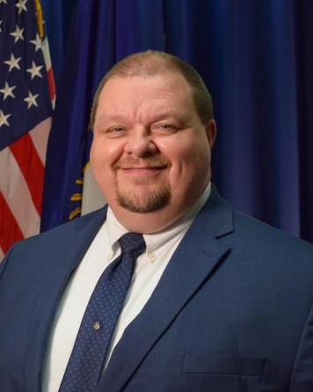

David Bradley began his career with the department as a Classification and Treatment Officer at Little Sandy Correctional Complex (LSCC) in 2005.  In 2007, Bradley laterally transferred to Eastern Kentucky Correctional Complex (EKCC) where in 2013 he was promoted to Unit Administrator I and was assigned as the Pre-Release Coordinator for the institution.  Bradley was promoted again in 2016 to Unit Administrator II and was assigned to manage the Restrictive Housing Unit.  Bradley later was in charge of the Reentry Preparation Dormitory at EKCC where he worked closely with offenders nearing the end of their sentence.  In 2018, Bradley was promoted as the Education Branch Manager for the Division of Education where he provided oversight of the department’s academic and career and technical education services offered to offenders.  In 2019, Bradley was promoted to Deputy Warden at Little Sandy Correctional Complex where he provides supervision to department heads overseeing programs, classification, recreation, chapel, library, and medical services.

During his time in Corrections, Bradley has been a member of the LSCC Hostage Negotiation Team, institutional liaison for the Kentucky Offender Management System (KOMS), Network Analyst, and PREA Compliance Manager.  Bradley received the LSCC employee of the month in May 2006, the EKCC Employee of the Month twice in 2008 and in 2011, and the Governor’s Ambassador Teamwork Award in 2012.

Bradley is a 2012 graduate of the Commissioner’s Executive Leadership Development Program.  Bradley is a member of the Kentucky Council on Crime and Delinquency (KCCD) and is currently a member of the state board.  He previously served twice as President of the KCCD state board, member of the Board of Directors, and President of the Cave Run Chapter.   Bradley is also a member of the Southern State Correctional Association (SSCA).  Bradley has been a member in local organizations such as Kiwanis International, Rotary Club, Morgan County Schools District Improvement Board, UK-Morgan County Extension District Board Chairman, UK-Morgan County Extension Family Consumer Sciences Board, UK-Morgan County Extension Building Committee, and twice Chairman of the Morgan County Sorghum Festival Committee.

**Missy Howard**

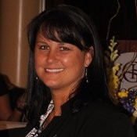

Missy Howard began her career with the Kentucky Department of Corrections on November 16, 2010, at Eastern Kentucky Correctional Complex as an Office Support Assistant II. In 2011, she promoted to Administrative Specialist II and in 2013 promoted to her current position, Administrative Specialist III. She was a recipient of employee of month in 2010 and 2015, and supervisor of the year the first quarter of 2020. She received the Commissioners achievement award in 2015 and graduated from EKCC Leadership S.A.I.L program in July 2018. In 2020 she was the recipient of the Mary Francis Cooper award. She has been a member of KCCD since 2012 and served as President of the Cave Run Chapter in 2018 and 2020. She has served as a board of director for the state KCCD since 2015. Missy is a member of Southern States Correctional Association. She has a big passion to help others and is always willing to go that extra mile to accomplish a job.

**Chrissy Lindon**

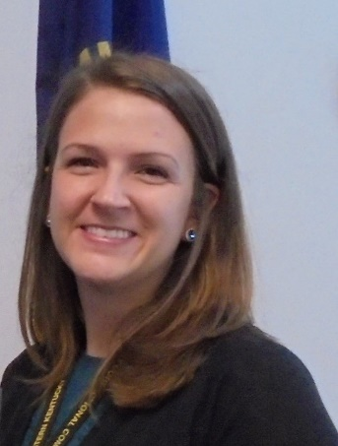

Chrissy Lindon began her career with the Department of Corrections in 2011 as an Office Support Assistant II in the Restrictive Housing Unit, Meritorious Housing Unit, and the Minimum Security Unit . In 2014, she was promoted to Administrative Secretary for the Deputy Warden of Programs. In 2016, she was promoted to Classification and Treatment Officer. In 2019, she was promoted to Corrections Unit Administrator I. In July 2021, she was promoted to Corrections Unit Administrator II. During her time at EKCC, she has worked intake, orientation, re-entry preparation dorm, minimum security unit, Meritorious Housing, and Restrictive Housing Unit. She assisted with opening the Transition Unit Program at EKCC, as well as converting a general population dormitory into an additional Restrictive Housing Unit. She has remained over the TU Program at EKCC since January 2018. A 2014 graduate of Morehead State University, Lindon earned her bachelor’s degree in University Studies. She earned employee of the month in 2018. She was a member of the facility’s Crisis Negotiation Team for 2018 and an active member of the EKCC Corrections Emergency Response Team and is a current Assistant Squad Leader.

Chrissy began membership of the Cave Run Chapter in 2012. She became the chapter secretary in 2013-2015, Chapter treasurer 2016-2017, Chapter Vice-President in 2018, and Chapter President in 2019 and current President of KCCD Cave Run Chapter. She was an elected KCCD State Board Member 2020-2021. Being a member of KCCD is a great opportunity to be involved in many avenues that allows you to help many people, and she enjoys being a part of the KCCD family. Go CATS and go PATS!!!!

**Rhonda May**

Rhonda May began her career with the Department of Corrections at Little Sandy Correctional Complex in April 2014. She promoted to Classification and Treatment Officer in October 2016 and Corrections Unit Administrator I in February 2022. She held the position of ADA Coordinator for 2 years, Assistant PREA Compliance Manager for 1 year, and is currently Grievance Coordinator. She has been a member of the Kentucky Council on Crime and Delinquency since 2018 and served two terms as Chapter President for the Laurel Gorge Chapter and one term on the State Board.

**Mark Noble**



Mark Noble started his career with the Department of Corrections in July 2008 as a Correctional Officer at Eastern Kentucky Correctional Complex. In September 2013, he promoted to a Production Coordinator for Kentucky Correctional Industries and in 2014; he promoted to the Operations Manager of KCI at EKCC.

He became a member of KCCD in 2011 and served as President of the Cave Run Chapter 2019-2020. He is a current member of the State Board from and has served on the Board since 2020 . Mark became a member of KCCD after KCCD had made a donation to him and his family during some health issues that he was having in 2011. He enjoys being a part of KCCD and paying forward what has been given to him.

**Jerimiah Prater**

Jerimiah began his career with the Department of Corrections in 2010 as a Correctional Officer at Northpoint Training Center, in 2012 He Transferred to Eastern Kentucky Correctional Complex. He was promoted to Correctional Sergeant in 2017, Correctional Lieutenant in 2018, and Training Coordinator at Southeast State Correctional Complex in 2020.

Jerimiah has been a member of the Kentucky Council on Crime and Delinquency (KCCD) since 2014. He wrote the Southeast chapter’s by laws and petitioned to have the Southeast Chapter instated in 2020. Jerimiah has served as the Chapter President of Southeast for two terms. He received the Achievement award in 2018 and the Mary Frances Cooper award in 2021.